

School of Future Tech

Case Study Report

REACT JS

Problem Statement No. - 190

Title - Device Screen Orientation & Motion Calibration Sandbox

Name - Stuti Saxena
Roll number - 150096725024
Batch - Larry Page
https://github.com/stutisaxena44/Device-Motion-Calibration-System-ReactJs
Live Link -
https://device-motion-calibration-system-re.vercel.app/
Index
- Problem Statement
- Tech Stack
- Component Architecture
- Features
- Screenshots
- Conclusion

Problem Statement
Modern mobile devices contain highly sensitive MEMS (Micro-Electro-Mechanical Systems) hardware, including tri-axial accelerometers and solid-state gyroscopes. Translating their raw, noisy hardware telemetry streams into stable spatial coordinate vectors requires processing real-time orientation matrices, handling angular coordinate singularities, and applying low-pass signal filtration.
This project solves this challenge by delivering a client-side device-motion hardware interceptor, mathematical filtering matrix, and high-frequency 3D vector visualizer built entirely in JavaScript. The application serves as an interactive mobile telemetry laboratory that captures hardware angular velocities, maps spatial tilt vectors, and runs real-time calibration routines with zero network latency and complete data privacy.

Tech Stack
- Frontend Framework: React 19 (bootstrapped with Vite)
- Styling: CSS Modules (App.module.css) combined with standard CSS variables and inline hardware-accelerated 3D CSS transforms.
- State Management: React Context API (TelemetryContext), combined with useReducer for structured application states and useRef for high-frequency volatile motion buffers.
- Hardware Integration: Native Web APIs (DeviceOrientationEvent and DeviceMotionEvent).
- Local Persistence: Browser localStorage API.

Component Architecture
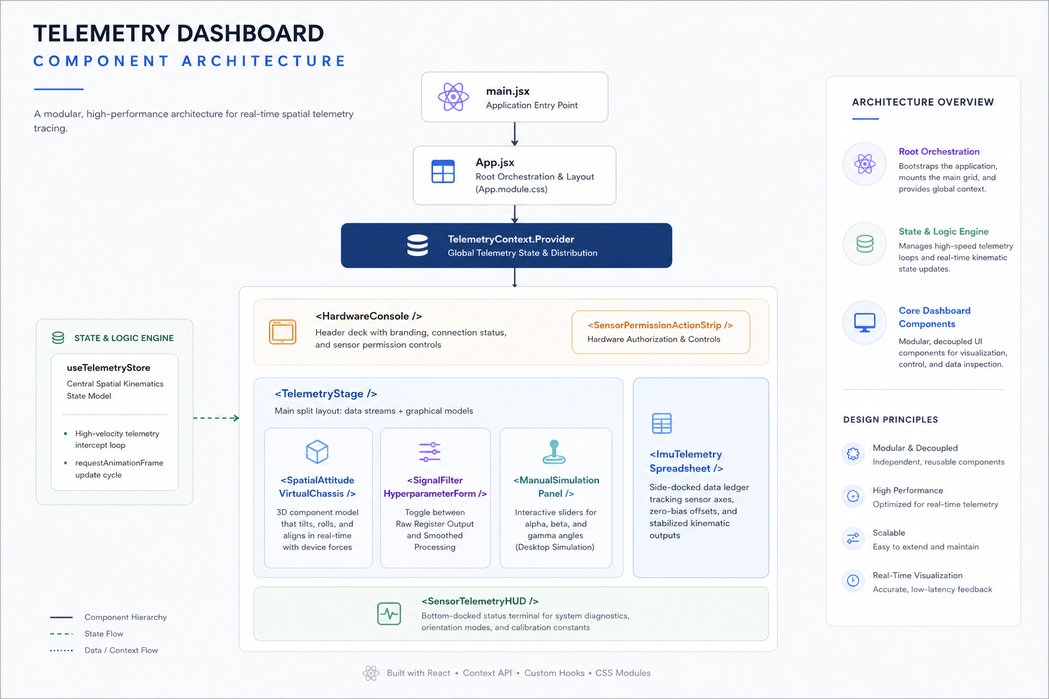

The application is structured into a highly decoupled, modular architecture within the src directory to guarantee high-performance real-time data tracing:
- Root Orchestration (main.jsx & App.jsx): Bootstraps the application, mounts the main grid (App.module.css), and wraps the application inside the TelemetryContext.Provider.
- State & Logic Engine: useTelemetryStore: A custom hook functioning as the central spatial kinematics state model. It manages the high-velocity telemetry intercept loop and processes requestAnimationFrame updates.
- Core Dashboard Components:
  - <HardwareConsole />: The primary header deck housing the project branding, connection source readouts, and the <SensorPermissionActionStrip /> which handles hardware authorization.
  - <TelemetryStage />: The main split layout orchestration component that pairs raw numeric data streams with graphical physics models.
  - <SpatialAttitudeVirtualChassis />: A 3D component model container that tilts, rolls, and aligns in real-time, matching the physical forces of the device.
  - <SignalFilterHyperparameterForm />: Form controls allowing engineers to toggle between Raw Register Output and Smoothed Processing.
  - <ManualSimulationPanel />: An interactive fallback panel utilizing sliders for desktop simulation of alpha, beta, and gamma angles.
  - <ImuTelemetrySpreadsheet />: A side-docked data ledger tracking logging structural values for sensor axes, zero-bias offsets, and stabilized kinematic outputs.
  - <SensorTelemetryHUD />: A bottom-docked status terminal documenting system diagnostics, orientation flag modes, and calibration constants.

Features
- High-Frequency Telemetry Intercept Engine: The application hooks directly into the browser's native API boundaries, handling high-velocity sensor streams ticking up to 60 times per second. By decoupling React state from the animation frame loop (requestAnimationFrame), it modifies DOM matrix transforms directly, avoiding UI lag.
- Signal Noise Complementary Filter: To resolve gyroscope drift and accelerometer vibration noise, the sandbox runs a mathematical filtering pipeline. It blends inputs via a tunable algorithm to eliminate jitter and output a smooth vector stream.
- Dynamic Sensor Bias Calibration: Includes an active "Zero-Calibration Routine". By sampling IMU streams over a brief frame window, it computes the arithmetic mean offset and saves these as negative vector constants to neutralize structural hardware inaccuracies.
- Hardware-Accelerated 3D Chassis Matrix: A visually rich, multi-layered 3D virtual smartphone that perfectly mimics the physical hardware's orientation (Pitch, Roll, Yaw) using pure CSS 3D transforms connected to the active data stream.
- Interactive Desktop Simulation Studio: For testing on hardware without physical sensors, users can utilize the interactive multi-axis sliders, or click and drag across the viewport to manually inject telemetry data directly into the simulation ledger.
- In-Memory Ledger & CSV Export: Operates strictly as an in-memory spatial coordinate ledger without a database. Captured telemetry streams can be downloaded instantly to the user's machine as a formatted CSV data log.
- LocalStorage Memory Integration: Custom sensor calibration bias profiles and dashboard layout selections are saved directly to localStorage to ensure perfect reloading between sessions.

Screenshots
1. The Primary Diagnostic Dashboard
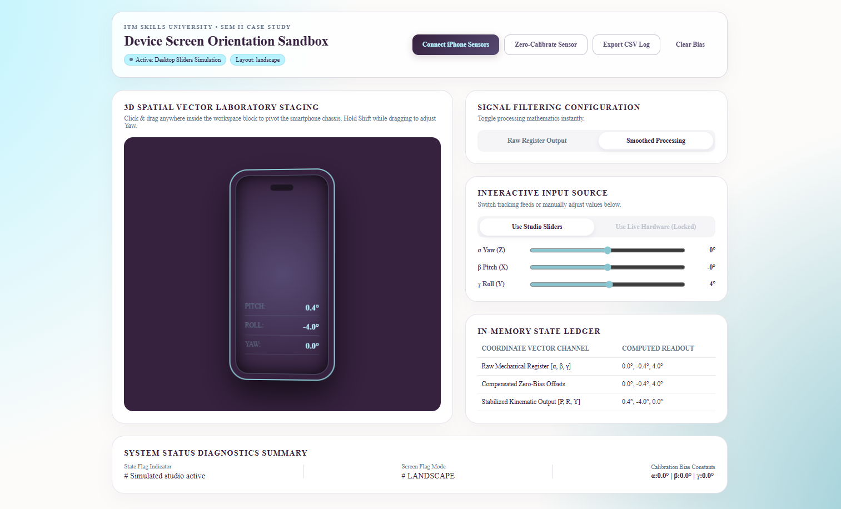
2. The 3D Spatial Virtual Chassis in Action
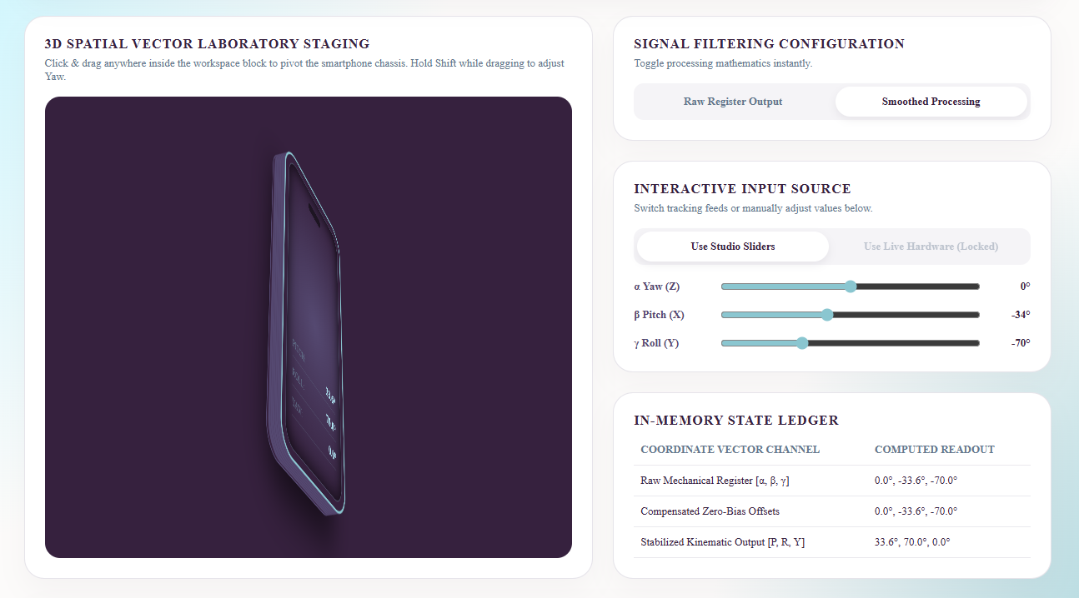
3. Hardware Access on Mobile (iPhone/iOS)
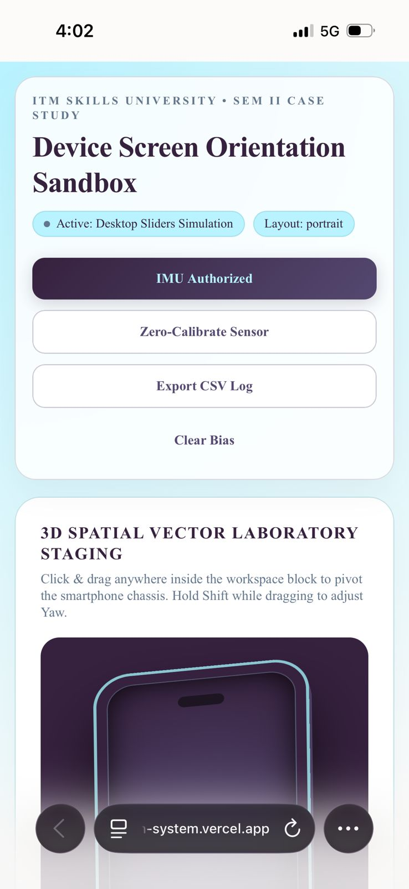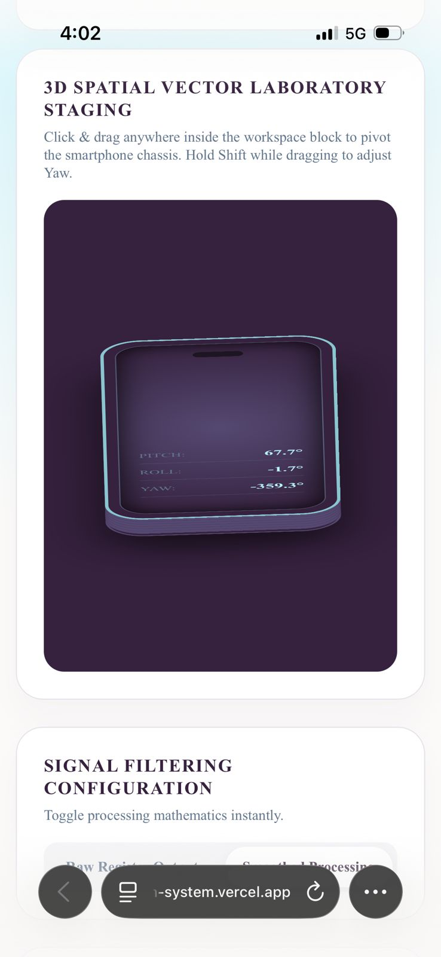

Conclusion
The Device Screen Orientation & Motion Calibration Sandbox effectively bridges the gap between hardware engineering and modern web development. By leveraging advanced React design patterns - such as decoupling volatile telemetry buffers from standard Context reconciliation - the application hits flawless 60 FPS performance entirely on the client side. The implementation of custom complementary filtering mathematics, a real-time 3D coordinate visualizer, and strict local storage management results in a premium, highly specialized laboratory tool that processes complex hardware signals with zero network latency.

